BIONIC ARM

**A report submitted in partial fulfillment of the Academic requirements for the award of the degree of Bachelor of Technology**

Submitted by

**AJAY BISHT 21H51A04P2**

**BELLAMKONDA BHUVAN KARTHIK 21H51A04P6**

**ASHELLI PAVAN GOUD 21H51A04P4**

**DAMERAKONDA NITHIN 21H51A04M4**

**NITIN GOJE 21H51A0438**

UNDER THE COURSE

# SOCIAL INNOVATION IN PRACTICE

 **CENTRE FOR ENGINEERING EDUCATION RESEARCH**

**CMR COLLEGE OF ENGINEERING & TECHNOLOGY**

# (Autonomous)

(NAAC Accredited with ‘A+’ Grade & NBA Accredited) (Approved by AICTE, Permanently Affiliated to JNTU Hyderabad)

KANDLAKOYA, MEDCHAL ROAD HYDERABAD-501401

**2022-2023**

# CENTRE FOR ENGINEERING EDUCATION RESEARCH

**CMR COLLEGE OF ENGINEERING & TECHNOLOGY (AUTONOMOUS)**

(NAAC Accredited with ‘A+’ Grade & NBA Accredited) (Approved by AICTE, Permanently Affiliated to JNTU Hyderabad) KANDLAKOYA, MEDCHAL ROAD, HYDERABAD-501401



CERTIFICATE

This is to certify that the report entitled **“Bionic Arm”** is a bonafide work done by Ajay Bisht(21H51A04P2), Bellamkonda Bhuvan Karthik(21H51A04P6), Ashelli Pavan Goud(21H51A04P4), Damerakonda Nithin(21H51A04M4), Nitin Goud(21H51A0438) of II B.TECH, in partial fulfillment of the requirements for the award of the degree of Bachelor of Technology, submitted to Centre for Engineering Education Research, CMR College of Engineering & Technology, Hyderabad during the Academic Year 2022-23.

**(**Names of the Project Coordinators)

1. Mr.G. Karthik Reddy(Asst. Prof) ECE/CEER **B.SURESH RAM**
2. Mr. S. Suresh(Asst.Prof) INF/CEER  **HOD CEER**



# DECLARATION

We, the students of II B. Tech I Semester of **Centre for Engineering Education Research** , **CMR COLLEGE OF ENGINEERING & TECHNOLOGY**, Kandlakoya, Hyderabad, hereby declare, that under the supervision of our course coordinators, we have independently carried out the project titled “**Bionic Arm**” and submitted the report in partial fulfillment of the requirement for the award of Bachelor of Technology in by the **Jawaharlal Nehru Technological University, Hyderabad (JNTUH)** during the academic year 2022-2023.

|  |  |  |
| --- | --- | --- |
| **NAME** | **ROLL NO** | **SIGNATURE** |
| AJAY BISHT | 21H51A04P2 |  |
| ASHELLI PAVAN GOUD | 21H51A04P4 |  |
| BELLAMKONDA BHUVAN KARTHIK | 21H51A04P6 |  |
| DAMERAKONDA NITHIN | 21H51A04M4 |  |
| NITIN GOJE | 21H51A0438 |  |



# ACKNOWLEDGEMENT

We are obliged and grateful to thank **B. Suresh Ram, Head (CEER), CMRCET**, for his cooperation in all respects during the course.

We would like to thank the Principal of **CMRCET, Major Dr.V.A.Narayana**, for his support in the course of this project work.

Finally, we thank all our faculty members Mr.G.Karthik Reddy(Asst.Prof) & Mr.S.Suresh(Asst.Prof)

Lab Assistants for their valid support.

We own all our success to our beloved parents, whose vision, love and inspiration has made us reach out for these glories.



# TABLE OF CONTENTS

|  |  |  |  |
| --- | --- | --- | --- |
| **CHAPTERS** | | **DESCRIPTION** | **PAGE No** |
|  |  | Abstract |  |
| 1 |  | Introduction | 1 |
| 2 |  | Literature Review | 3 |
| 3 |  | Problem Definition | 5 |
|  | 3.1 | Community interaction with the concerned project team | 5 |
|  | 3.2 | Problem Statement | 5 |
|  | 3.3 | Objective | 6 |
|  | 3.4 | Requirement Analysis | 6 |
|  | 3.5 | Methodology | 10 |
| 4 | 4.1 | Circuit Diagram | 11 |
|  | 4.2 | Conceptual Design | 12 |
|  | 4.3 | Block Diagram | 13 |
| 5 | 5.1 | Implementation | 14 |
|  | 5.2 | Conclusion | 15 |
| 6 |  | Future scope | 16 |
| 7 |  | Source Code | 17 |
| 8 |  | Appendix | 20 |
|  | 8.1 | Reference | 20 |
| 9 |  | Student Details | 21 |
|  |  | Poster | 22 |
|  |  | Team Photo | 23 |



**ABSTRACT**

There are many accident which occur in our day to day life As a result it may cause the loss of particular limbs which makes Life difficult for people after amputation.

Prosthetic arm is useful solution for providing artificial limb for disable people. Even though are many existing solution there are many existing solutions they lack in certain areas.

Our project name is BIONIC ARM. This documentation on our project gives a brief idea of the problem, gaps in the existing solution how we are going to solve them.



# CHAPTER 1

**INTRODUCTION**

A disability is a condition that a person has which limits them in some way.

These conditions may be congenital (present at birth), cognitive (to do with the brain), developmental (appears as the person develops), physical (for example, caused by an accident or infection), sensory, or a combination of factors.

The United Nations Convention on the Rights of Persons with Disabilities defines disability as:

"long-term physical, mental, intellectual or sensory impairments which in interaction with various barriers may hinder [a person's] full and effective participation in society on an equal basis with others".

Invisible disabilities, or hidden disabilities are disabilities that are not immediately obvious. Some examples of invisible disabilities are intellectual disabilities, autism spectrum disorder, attention deficit hyperactivity disorder, mental disorders, asthma, epilepsy, allergies, migraines, arthritis, and chronic fatigue syndrome.

People with a disability or disabilities may need to use special equipment that can help them. This can include using a wheelchair, a cane or walking stick, hearing aids, a teletypewriter (TTY) and using specially designed software and hardware for the personal computer.

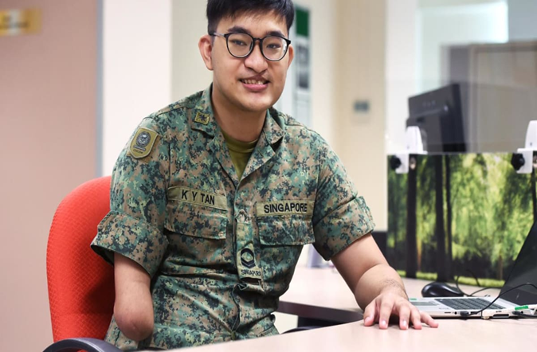

Fig1:- person with disability



As we have some idea regarding amputation how its helpful and have ability to change disable people life but in many ways it also carries many side effects and adverse effect on people which include physical , economical , psychological and socially.It include heart problems such as heart attack ,deep vain thrombosis, slow wound healing and wound infection, pneumonia ,stump and phantom limb pain.The term phantom does not mean the sensations re imaginary. Phantom limbs pain is a real phenomenon, which has been confirmed using brain imaging scans to study how nerve signals are transmitted to the brain .

The symptoms of phantom limb pain can range from mild to severe. Some people have described brief flashes of mild pain, similar to an electric shock ,that last few seconds.

The loss of a limb can have a considerable psychological impact . Many people who ve had an amputation report emotions such as grief and bereavement , similar to the experiencing the death of a loved one.Common emotions and thoughts experienced by people after an amputation include depression , anxiety , denial ,grief and feeling suicidal .

People who had an amputation as a result of trauma also have an increased risk of developing post traumatic stress disorder .



# CHAPTER 2

**LITERATURE REVIEW**

## The link between having a lower-limb amputation and being disabled might seem self-evident. Indeed, the medical model of disability would suggest that lower-limb amputation causes disability, and that all lower-limb amputees are disabled people. Conversely, social models of disability would argue that limb loss does not determine disability, but that disabilities are rather caused by social structures and prejudices, while the interactional model suggests that there are both individual and social causes of disability. This paper draws on interviews with nine lower-limb amputees to address amputees' own accounts of disability, in order to determine how (if at all) they make links between being an amputee and being disabled. The analysis shows that participants draw on various models of disability, as well as their own lived experiences, to construct subjective and diverse definitions of disability. Three interlinking definitions of disability recurred across the data: disability as a measure of personal (in)abilities; disability as a stigmatizing mask; and disability as an official status. Overall, disability was constructed as a complex, context-dependent label, which could not be reduced to any singular concept.

### **Body-powered partial hand prosthesis:**

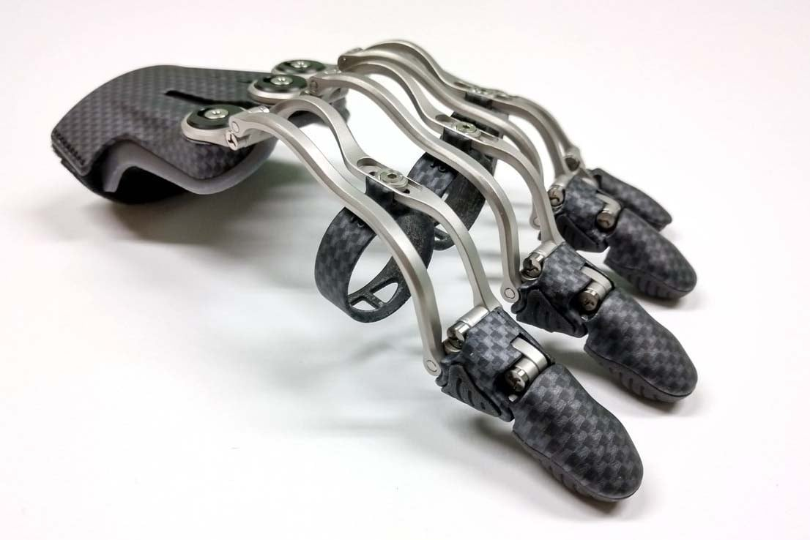

Fig 2:-Body-powered partial han



Disadvantages:

It is costly and we need to always look at the video continuously.

Cost**:**

Around ₹70,00,000

### **Electrically powered partial hand prosthesis:**

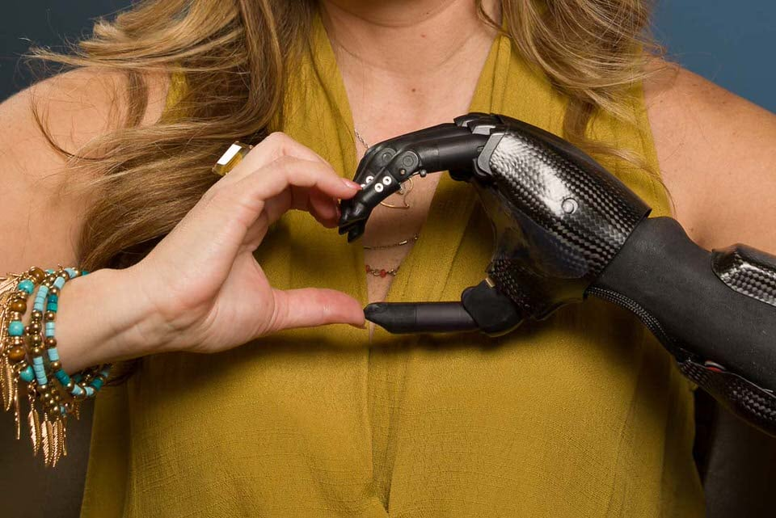

Fig 3:- Electrically powered partial hand

Disadvantages**:**

Its costs high.

Cost**:**

Around ₹50,00,000





# CHAPTER 3

**PROBLEM DEFINITION**

# COMMUNITY INTERACTION WITH THE CONCERNED PROJECT TEAM:

The intended audience for prosthetic wrists includes individuals who have experienced limb loss or have congenital limb differences affecting their wrist function. This can encompass a diverse range of people, such as:

**Amputees**: Prosthetic wrists are commonly used by individuals who have undergone amputation of the hand or lower forearm due to trauma, disease, or other medical conditions.

**Individuals with congenital limb differences**: Some individuals are born with conditions that affect the development or function of the wrist, such as limb reduction or dysmelia. Prosthetic wrists can provide them with improved mobility and functionality.

**Prosthetic users seeking wrist function**: People who already use a prosthetic hand or forearm prosthesis may opt for a prosthetic wrist to enhance their overall upper limb functionality. A prosthetic wrist can complement the existing prosthesis and provide additional capabilities.

**Those with impaired wrist function**: Individuals who have limited wrist movement due to conditions like arthritis, nerve injuries, or other musculoskeletal disorders may benefit from a prosthetic wrist to restore or augment their wrist function.

# PROBLEM STATEMENT:

Problem faced by disable people after amputation of particular body part.



# OBJECTIVE

Our main objective of creating the device is to provide individuals with a functional and versatile replacement for a natural arm that may have been lost or impaired due to amputation, injury, or other medical conditions. A bionic arm, also known as a prosthetic arm or robotic arm, incorporates advanced technologies to simulate the movements and capabilities of a biological arm.

# REQUIREMENT ANALYSIS:

The materials and the devices needed for making bionic wrist

1)7 Servo motors

2)Voice recognition module

3)Arduino uno

4)Battery or power supply

5)Arduino v5 sensor shield expansion board

6)3d printed exo-skeleton or wooden model

8)Jumper wire



## SOFTWARE DESCRIPTION

1. Arduino tool (IDE) version 1.8.15

## Power Supply:

In the circuit, Arduino board, LCD module and LEDs need a 5V regulated DC for their operation. To achieve this, a DC power adapter is used. An LED along with a 10K Ω pull-up resistor can also be connected between common ground and output pin to get a visual hint of supply continuity.

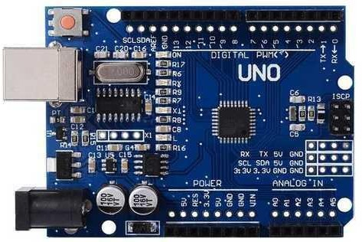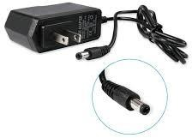

## Fig.6-Arduino Uno Board Fig 7-Dc Power supply adapter 5v



**Ultrasonic Sensor:**

Ultrasonic Sensor HC-SR04 is a sensor that can measure distance. It emits an ultrasound at 40 000 Hz (40kHz) which travels through the air and if there is an object or obstacle on its path It will bounce back to the module. Considering the travel time and the speed of the sound you can calculate the distance.

The configuration pin of HC-SR04 is VCC (1), TRIG (2), ECHO (3), and GND (4). The supply voltage of VCC is +5V and you can attach TRIG and ECHO pin to any Digital I/O in your Arduino Board.

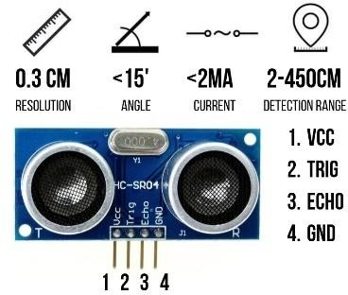

## Fig 8: Ultrasonic Sensor

**ARDUINO IO EXPANION SHILED:**

The Arduino I/O Expansion Shield provides an easy way to connect sensors, servos and RS485 device to Arduino board. It expands Arduino's Digital I/O and Analog Input Pins with Power and GND. It also provides separate PWM Pins which are compatible with standard servo connector.

Arduino Shields are add-on boards than can be plugged on top of an Arduino board and provided additional capabilities and functionalities to an Arduino Board. They have the same pin position as an Arduino Board and are usually designed to implement a specific function.



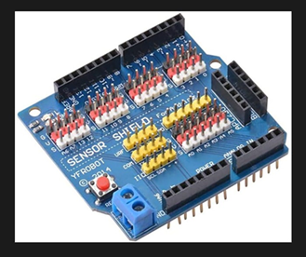

Fig 9:- Arduino expansion shield

**SERVO MOTOR:**

A servo motor is a rotary actuator that allows for precise control of angular position. It consists of a motor coupled to a sensor for position feedback. It also requires a servo drive to complete the system. The drive uses the feedback sensor to precisely control the rotary position of the motor.

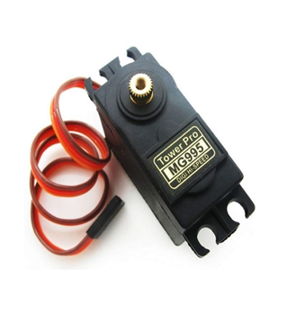

Fig 10 :- servo motor



**VOICE MODULE:**

The Grove Speech Recognizer module is equipped with a built-in microphone, a speech recognition chip, and a Grove connector for simple connectivity. It utilizes voice recognition algorithms to convert spoken words into digital signals that can be processed by a microcontroller or other hardware platforms.

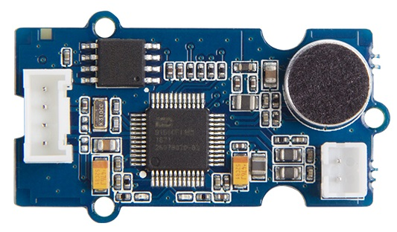

Fig 11:-voice module

* 1. **METHODLOGY:**

This project is completely depends upon the code we write and the sensors we use. In the code, we write that when the sensor senses the sound and the type of input it want, and moves the direction of motor it displays the out put on the console.When a person give a command by giving some voice to recognize, the sensors in the device senses the speech of its and perform some task with help of servo motor displays it on the console.



# CHAPTER 4

* 1. **CIRCUIT DIAGRAM:**

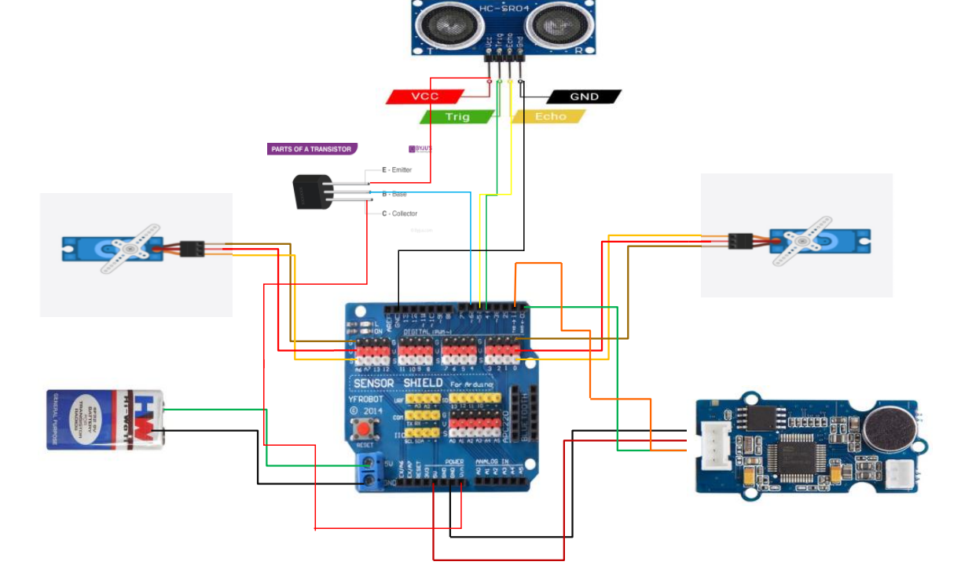

Fig 12:-circuit



* 1. **CONCEPTUAL DESIGN:**

Bionic arm can carry a particular amount of load and its mechanism is such that it can be controlled by a muscle , brain signal or voice command for to perform an task.The design of the bionic arm will depend upon the damage of an arm.

The project use Arduino voice recognition module v3 sensor for moving servo motor Voice sensor allow user to measure’s sound generated by mouth when person is giving command with the help of micro phone which is an input for an user.The voice module send the data to Arduino uno for the compilation of command’s After compilation the main board execute the output with help of servo motor .The servo motor are capable of opening up their fingers for to grape an object or material

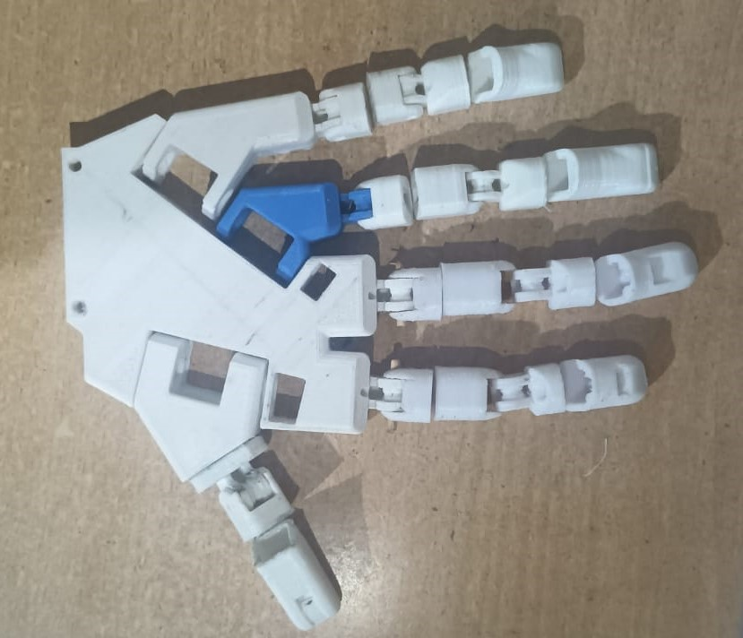 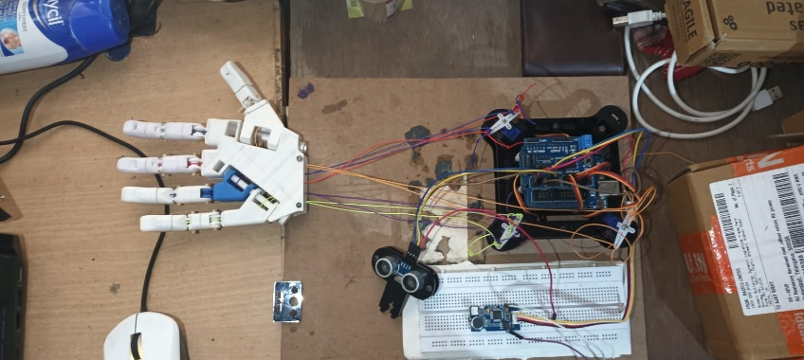

Fig 13:- conceptual design



* 1. **BLOCK DIAGRAM:**

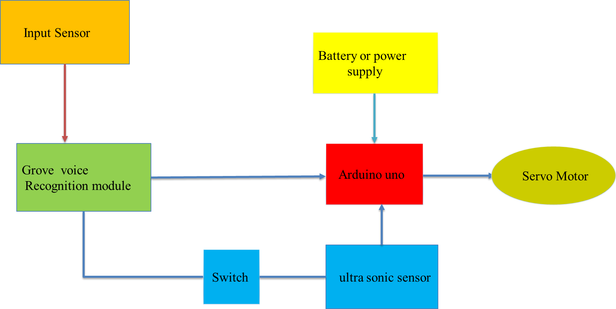

Fig 14:- Basic block diagram of bionic arm



# CHAPTER 5

* 1. **IMPLEMENTATION:**

In this method the idea is just to tie a thread or a fishing line at the top of the fingers and the same thread attached on the wrist or somewhere on the forearm then with rotation of the wrist the thread s are pulled

Back and the fingers are consequently fold .To perform this method you must have movement of the wrist other wise you cannot pull the string So these prosthetic uses servo motors for to pull the string which will allow the movment of fingers to hold or grap and object with help of voice control module which will take input form user and send to the Arduino board .the motor will be connected to expansion board which allow the connection of sensor or actuators.

* 1. **CONCLUSION:**

The aim of this project was to redesign a prosthetic arm to meet the need of amputees with low cost.By completing this project, we conclude by saying that the person of the current advancement in technology. Whether it is because of ignorance or lack of affordability ,Apparently our product is most feasible, affordable, plausible solution to the existing problem. Hopefully, our project might stand as a diligent drop of advancement for amputes and social innovation and help the people.



# CHAPTER 6

**FUTURE SCOPE**

The range of capabilities and functionalities it offers to individuals who use it as a prosthetic limb. The scope can vary depending on the specific design, technology, and features incorporated into the bionic arm. Here are some key aspects that define the scope of a bionic arm:

**Range of motion:** The scope of a bionic arm includes the ability to replicate a wide range of movements and gestures that mimic those of a natural arm. This can involve flexing and extending the elbow, rotating the forearm, and providing dexterity and precision in finger movements.

**Gripping and manipulation:** Bionic arms are designed to enable users to grasp and manipulate objects with various grip patterns, force levels, and coordination. The scope may include features such as pinch grips, power grips, and fine motor control to handle objects of different shapes, sizes, and weights.

**Control systems:** The scope of a bionic arm encompasses the control mechanisms used to operate and command the prosthetic limb. This can range from basic mechanical switches and cables to more advanced myoelectric control, where muscle signals from the residual limb are used to trigger specific movements of the bionic arm.



# CHAPTER 7

**SOURCE CODE**

#include <SoftwareSerial.h>

#include <VarSpeedServo.h>

VarSpeedServo servo8;

VarSpeedServo servo1;

VarSpeedServo servo7;

#include <NewPing.h>

#define SOFTSERIAL_RX_PIN 2

#define SOFTSERIAL_TX_PIN 3

#define TRIGGER_PIN 4

#define ECHO_PIN 5

#define MAX_DISTANCE 200

const int LED_PIN = 6;

SoftwareSerial softSerial(SOFTSERIAL_RX_PIN, SOFTSERIAL_TX_PIN);

NewPing sonar(TRIGGER_PIN, ECHO_PIN, MAX_DISTANCE);

const char *voiceBuffer[] = {

"Turn on the light",

"Turn off the light",

"Play music",

"Pause",

"Next",

"Previous",

"Up",

"Down",

"Turn on the TV",

"Turn off the TV",

"Increase temperature",

"Decrease temperature",

"What's the time",

"Open the door",

"Close the door",

"Left",

"Right",

"Stop",

"Start",

"Mode 1",

"Mode 2",

"Go",

};

void setup()

{

Serial.begin(9600);

softSerial.begin(9600);

softSerial.listen();

servo8.attach(8);

servo1.attach(13);

servo7.attach(10);

servo1.slowmove(60,90);

servo7.slowmove(90,90);

servo8.slowmove(52,90);

delay(1000);

pinMode(LED_PIN, OUTPUT);

}

void loop()

{

if (softSerial.available())

{

char cmd = softSerial.read();

if (cmd >= 1 && cmd <= sizeof(voiceBuffer) / sizeof(voiceBuffer[0]))

{

Serial.println(voiceBuffer[cmd - 1]);

if (strcmp(voiceBuffer[cmd - 1], "Down") == 0)

{

servo1.slowmove(0,50);

servo7.slowmove(0,50);

servo8.slowmove(0,50);

}

else if (strcmp(voiceBuffer[cmd - 1], "Go") == 0)

{

servo1.slowmove(110,50);

servo7.slowmove(110,50);

servo8.slowmove(110,50);

}

else if (strcmp(voiceBuffer[cmd - 1], "Up") == 0)

{

servo1.slowmove(130,50);

servo7.slowmove(140,50);

servo8.slowmove(130,50);

}

else if (strcmp(voiceBuffer[cmd - 1],"Start" ) == 0)

{

digitalWrite(LED_PIN, HIGH); // Turn on the LED

}

else if (strcmp(voiceBuffer[cmd - 1], "Stop" ) == 0)

{

digitalWrite(LED_PIN, LOW); // Turn off the LED

}

// Add more conditions for other commands here

}

}

// Ultrasonic sensor code

unsigned int distance = sonar.ping_cm();

if (distance > 0 && distance < 10) // Adjust the distance threshold as needed

{

servo1.slowmove(120,40);

servo7.slowmove(120,40);

servo8.slowmove(120,40);

delay(1000);

servo1.slowmove(20,40);

servo7.slowmove(20,40);

servo8.slowmove(20,40);

// Rotate the servo to a specific angle

// Wait for 1 second (adjust as needed)

    }

}



# CHAPTER 8

**REFERENCES**

[https://images.vivintcdn.com/global/vivint.com/resources/products/doorbell-](https://images.vivintcdn.com/global/vivint.com/resources/products/doorbell-camera/doorbell-camera-delivery-ring-doorbell.jpg) [camera/doorbell-camera-delivery-ring-doorbell.jpg](https://images.vivintcdn.com/global/vivint.com/resources/products/doorbell-camera/doorbell-camera-delivery-ring-doorbell.jpg)

[https://d3mvlb3hz2g78.cloudfront.net/wp-](https://d3mvlb3hz2g78.cloudfront.net/wp-content/uploads/2013/05/thumb_720_450_Doorbell.jpg) [content/uploads/2013/05/thumb_720_450_Doorbell.jpg](https://d3mvlb3hz2g78.cloudfront.net/wp-content/uploads/2013/05/thumb_720_450_Doorbell.jpg)



# CHAPTER 9

**STUDENT DETAILS:**

## TEAM 14:

## 

**NAME : ASHELLI PAVAN GOUD**

**H.T No : 21H51A04P4**

**BRANCH : ECE**

**MOBILE NO: 9640771900**

**CMRCET**

## 

**NAME : BELLAMKONDA BHUVAN KARTHIK**

**H.T No : 21H51A04P6**

**BRANCH : ECE**

**MOBILE NO:8328024854**

**CMRCET**

## 

**NAME : AJAY BHIST**

**H.T No : 21H51A04P2**

**BRANCH : ECE**

**MOBILE NO:7032815388**

**CMRCET**



**NAME : DAMERAKONDA NITHIN**

**H.T No : 21H51A04M4**

**BRANCH : ECE**

**MOBILE NO:7658960114**

**CMRCET**

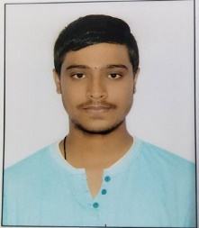

**NAME : NITIN GOJE**

**H.T No : 21H51A0438**

**BRANCH : ECE**

**MOBILE NO:7893157323**

**CMRCET**